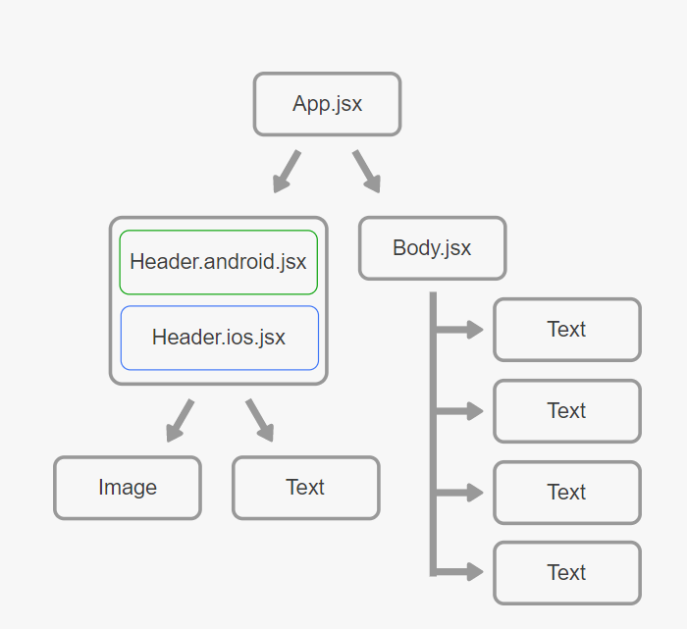**React Native vs Native (iOS, Android)**

Introduce to react native

React Native is a develop platform which allows people develop apps across platforms simultaneously. React use JavaScript library for building UI so that the native development is combined. It provides components like *view, text,* and *image* that map to the UI building blocks directly, and wrap native components such as *ProgressViewIOS* for iOS or *ViewPagerAndroid* for Android as well.

Pros:

This tool provides cross platform development while sharing the same codes, which means only one team of developers needed for both iOS and Android app development and maintenance.

Source: <https://facebook.github.io/react-native/>

React Native is based on JavaScript library, which is popular in webpage development. So it may not be a brand-new language for programmers (unlike swift).

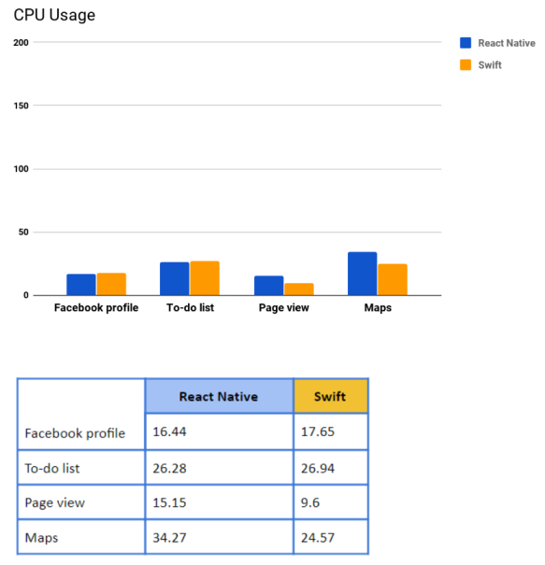Users will have consisted experience when they are using different devices. They do not need to explore the new features if they want to use the same app – they will be all the same.

Cons

Although it is a cross-platform development tool, since there are differences in android and iOS, it is impossible to completely using the same design without any native platform-specific code in some cases, and it is then break the advantage of itself as a cross-platform tool.

Since it is been combined by automatic tools, the performance of developed app must be in compensate of developing efficiency. React is not able to interpret your code into a well-designed native app as it should be as people developing using native develop tools. As a result the performance (mostly running speed) will be slower for react native. Especially when the app goes more complex with more features, React may not handle it as expected, and it is possible that the app just become slow and make users experience very bad.

Source:https://codeburst.io/react-native-vs-real-native-apps-ad890986f1f

Recommandation:

For people who are trying to develop simple, functionality directed app, while it do not require high resource consumption and performance, it might be good to use react natives. It make developers easier and the advantages stated can applly. However when people are trying to develop either iOS or android apps, which is specific connected to the attributes of platform itself(like certain APIs), or apps that requirs high performance, it might be better, even have to separate into two groups, develop using native tools.

References:

1. React Native · A framework for building native apps using React. (n.d.). Retrieved from https://facebook.github.io/react-native/.Technology, W. (2018, July 26).

2.React Native vs Real Native Apps. Retrieved from https://codeburst.io/react-native-vs-real-native-apps-ad890986f1f.